Git command

Git init

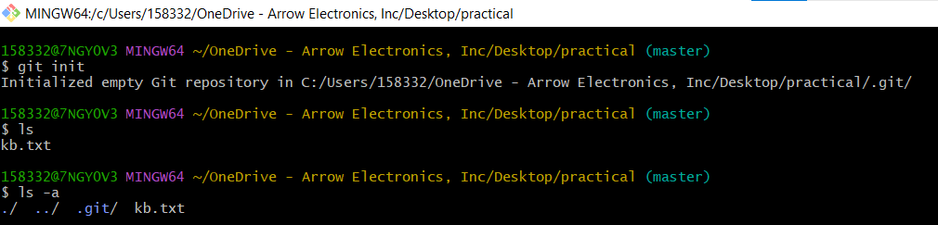

Git status

Git commit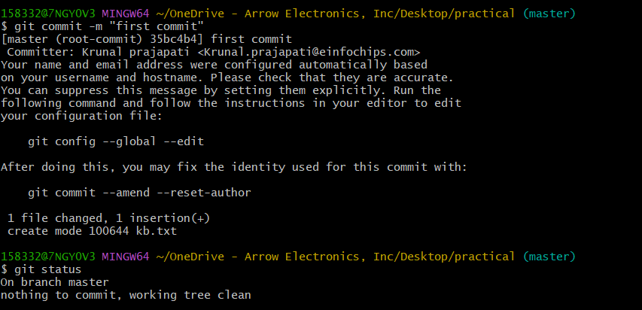

Git diff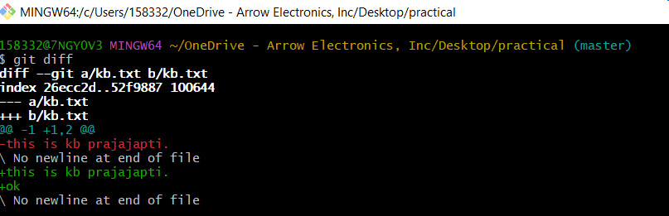

Git add

Git remove file

Git log

Git add

Git reset

Git branch

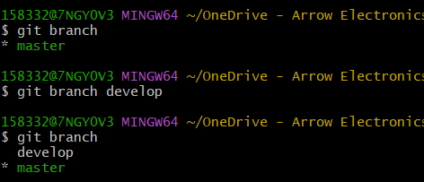

Git checkout

Git merge

Git show

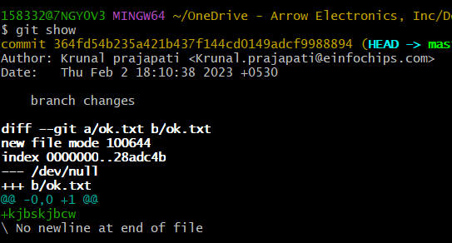

Github commands:

Git add to origin





Git push

Git clone

